Template for the preparation of extended abstract for ISFV21, 2025

Author Full Name, 1,2,* Author Full Name, 2 and Author Full Name 3

1 Institution, Adress, Country

2 Institution, Adress, Country

3 Institution, Adress, Country

*Corresponding author: email address of the corresponding author

**ABSTRACT** : *The ISFV21 proceedings will be published electronically. This is a brief guide to help you prepare papers in a uniform style for this ‘electronic’ publication. Please insert here a brief abstract of your paper of about 200 words.*

**Keywords**: at least 3 words and no more than 5 words

1 Title of Section (e.g. Introduction, Experimental, Results and Discussion)

This template shows how to prepare an extended abstract in the ISFV21 proceedings. It illustrates the paper layout, and describes points you should notice before you submit your papers. The papers will be in A4 size with margins top 30 mm, left and right 20 mm, bottom 25 mm.The text should be Times or Times Roman with font size 12 point. An extended abstract must be no more than 10 pages.

1.1 Headers and Footers

Notice the ‘ISFV’ logo should only appear on page 1. In this Word template there should be a section break after the abstract of page 1 to ensure this. After page 1 even numbered pages have authors names only, right justified in the header. Odd numbered pages have the title only in the header, right justified.

Footers contain the page number and the symposium references “ISFV21 – Tokyo / Japan – 2025’, left justified.

2 Preparation and Submission of an Electronic Paper

2.1 Use of Templates

The papers should be prepared, if possible, using the supplied template (Microsoft Word).

2.2 General Procedures for Submission and Software Used and Final Paper Format

The extended abstract must be submitted in “PDF” format via the ISFV21 website <https://www.isfv21.org/index.html>. Only corresponding authors will be able to connect to the submission tool with login and corresponding password.

The pdf file size of the paper should not exceed 4 MB. When creating your pdf file please select “include all embedded fonts.”

2.3 Diagrams and Figures

Care should be taken over the preparation of diagrams and figures which may incorporate color where it adds to the presentation. Figures will either be entered in one column or two columns and should be 80 mm or 170 mm wide respectively. A minimum line width of 1 point is required *at actual size*. Annotations should be in 10 point with the first letter only capitalized. The figure caption should be preceded by “Fig.” followed by the figure number. For example, “Fig. 1 Granular impact cratering…….”

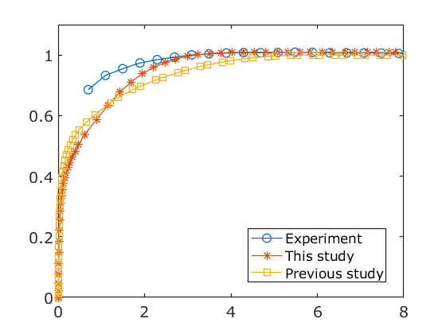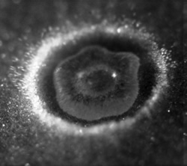

Fig. 1 Granular impact cratering by a water droplet. Fig. 2 Example plots.

2.4 Photographs and illustrations

Authors should recognize the possibility for full color publishing of photographs and illustrations. Image files should be optimized to minimize size without compromising the quality. The figures should have a resolution of 300 dpi.

2.5 Equations

Using the appropriate editor each equation should occur on a new line with uniform spacing from adjacent text as indicated in this template. The equations, where they are referred to in the text, should be numbered sequentially and their identifier enclosed in parenthesis, right justified. The symbols, where referred to in the text, should be italicized.

$$\begin{aligned}S=k_{B}\ln{W}.\# LISTNUM NumberDefault \backslash l 4 \end{aligned}$$

3 General Style Preferences

3.1 Style of Writing

Papers are accepted on the basis that they may be edited for style and language. The author himself is responsible for the correctness of the scientific content. Abbreviations should be spelt out in full the first time they appear and their abbreviated form included in brackets immediately after. Words used in a special context should appear between single quotation marks the first time they appear.

3.2 References

3.2.1 Description

The papers in the reference list must be cited in the text. In the text the citation should appear in square brackets “[]”, as in, for example, ‘the red fox has been shown to jump the black cat [3] but not when....” In the Reference list the font should be Times or Times New Roman with 10 point size. The Author name list should be terminated by a ‘full stop’. The citation number should be enclosed in brackets.

Book titles should be in *italics*, followed by a “full stop.” Proceedings or journal titles should be in *italics.* Only the first letter of the title should be capitalized in the article name as follows:

References

1. Smith J, Jones B and BrownJ**.** *The title of the book*. 1st edition, Publisher, 2001.
2. Smith J, Jones B and Brown J. The title of the conference paper. *Proc* C*onference title*, where it took place, Vol. 1, paper number, pp 1-11, 2001.
3. Smith J, Jones B and BrownJ. The title of the journal paper. *Journal Name*, Vol. 1, No. 1, pp 1-11, 2001.

Copyright Statement

The authors confirm that they, and/or their company or institution, hold copyright on all of the original material included in their paper. They also confirm they have obtained permission, from the copyright holder of any third-party material included in their paper, to publish it as part of their paper. The authors grant full permission for the publication and distribution of their paper as part of the ISFV21 proceedings or as individual off-prints from the proceedings.